**About Me**

Merhaba!!! Which means hello in Turkish. My name is Alpha Ugur, and I was born in Birmingham, Alabama. Despite not staying there for long and being moved around between foster homes, I eventually found my forever family in Madison, Wisconsin. Since then, my life has been filled with endless love, laughter, and exciting adventures. I have a friendly atmosphere and enjoy playing with kids and getting attention from all kinds of people. I share my family's passion for helping others and I strongly believe that mental health matters. As a dog, I may not be able to offer traditional assistance, like talk therapy (that's my mom’s job) but I know that my presence and love can make a difference in people's lives. I am so excited to be part of your healing journey, and also to get lots of love and cuddles!

**Hobbies**

During my free time, I love to take walks with my parents. I love nature walks, especially if my parents and I are going hiking. Madison has some really nice views. I also love going to the dog park to hangout with all my friends. This is how we get to catch up, and I tell them all about my fun experiences when I work with people who come from different diverse backgrounds. I love it! When I am really tired, I self-care by taking super long naps, and once in a while indulge in Vanilla Ice Cream.

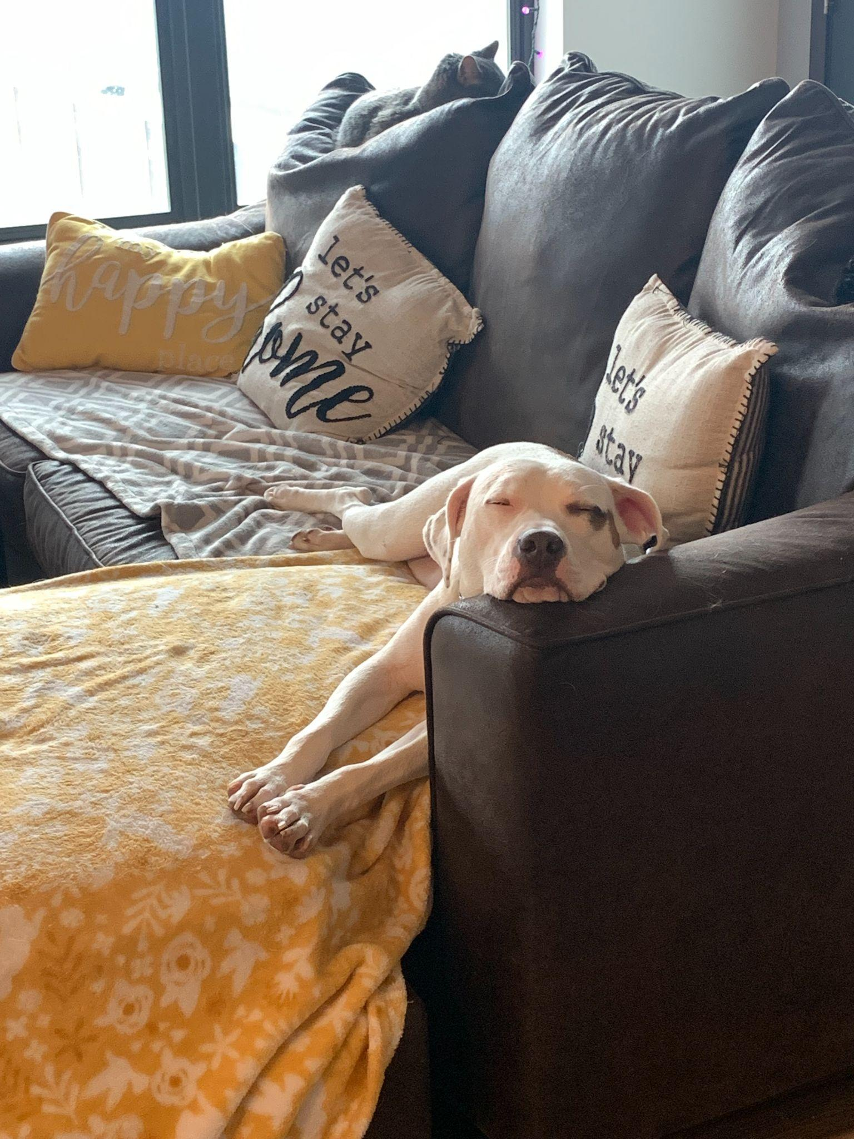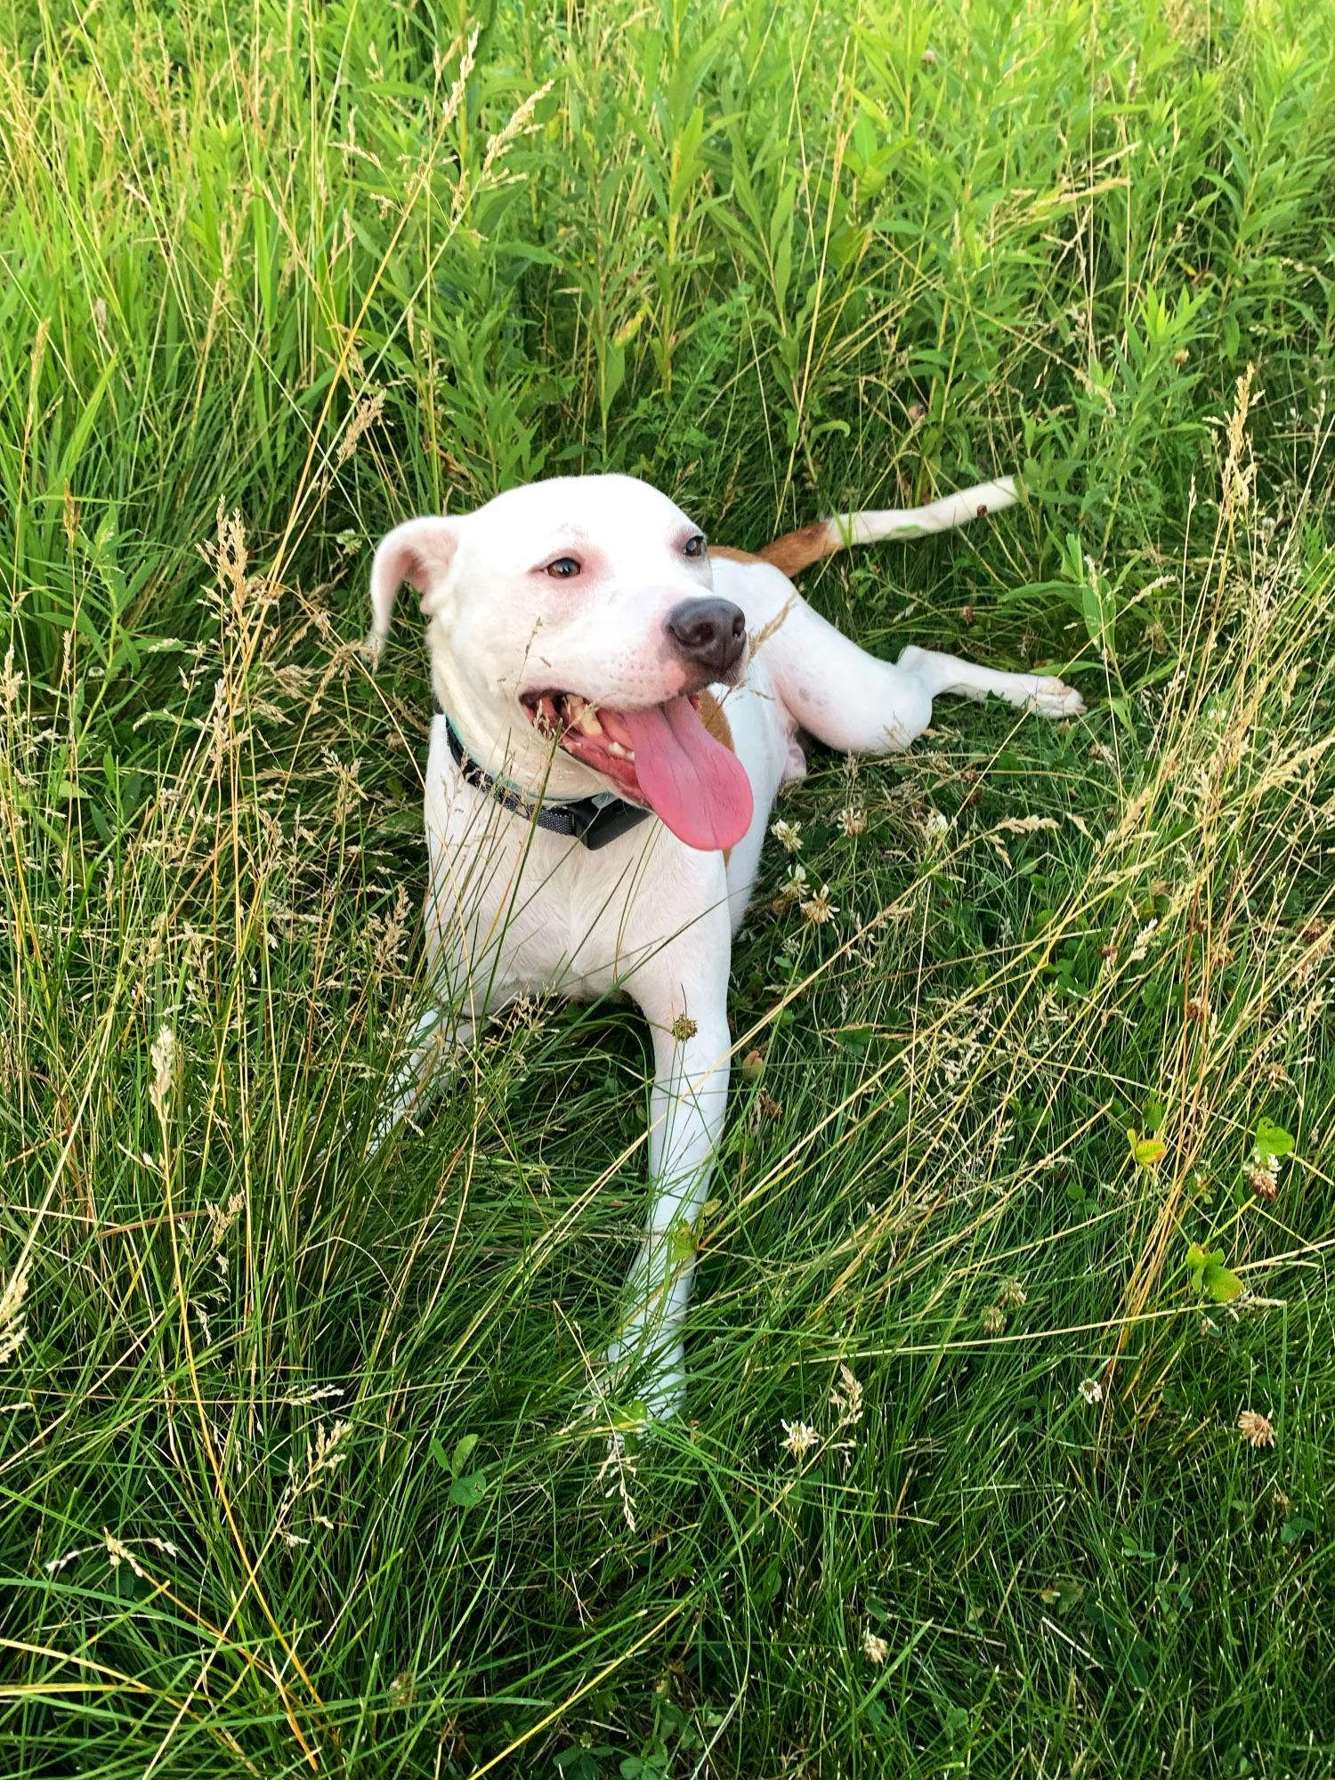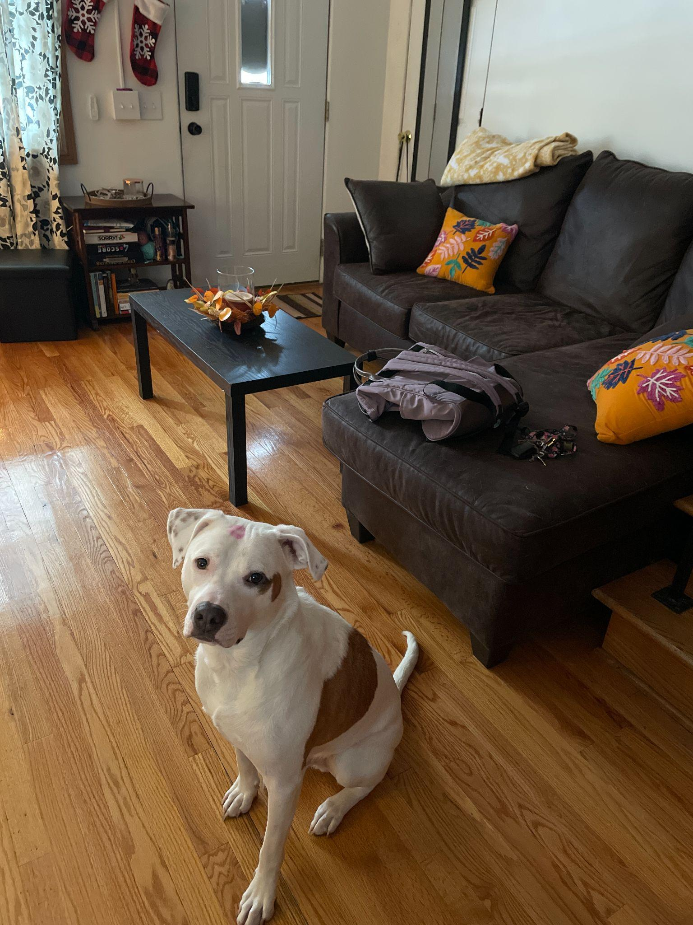

How will I Assist?

I will be assisting in many ways during the therapy session. I will follow the lead of my mom (your therapist) during the session. She will direct me and I will follow. I will mostly be helping with emotional areas of regulation. There has been research that has shown stress can impact physical, emotional, and cognitive areas. In my portfolio you will see through visual pictures more indepth how I help with stress. The main goal is for you and I to connect and bond. It will take time. We can go at your own pace. I tend to help clients to relax through petting, or taking care of me during sessions. When this happens there is a chemical that is released in your brain called dopamine, this helps you feel happy but also allows you to feel relaxed.

Once you have reviewed the visuals below that gives more information on my interactions during sessions and how I help. You will then need to review the documents that tell you I am updated with my health screen and up to date with my vaccinations. Once you have reviewed these important documents, you will then read the informed consent about our work together. Should you have any questions, please let my mom (Jennifer) know and she will answer any questions and address any concerns you may have. If you decide to proceed with Animal Assisted Therapy/Pet Therapy (where I come in) you will then be directed to sign the informed consent. Look forward to meeting you!

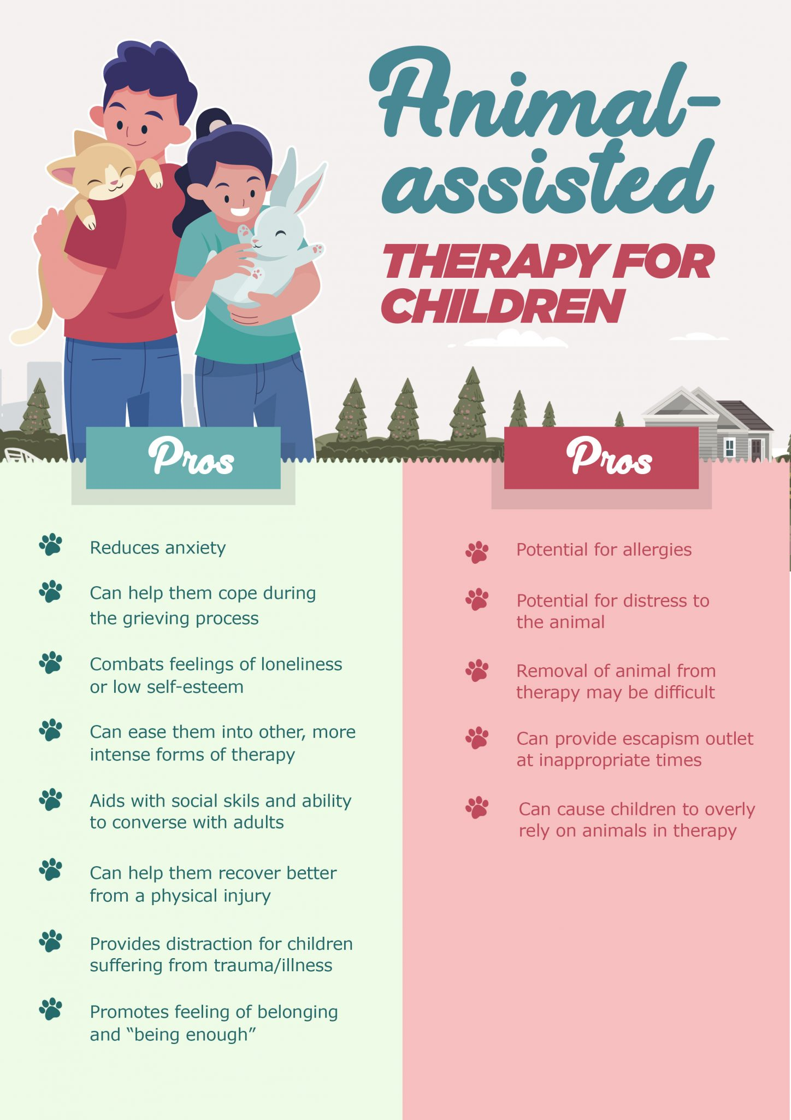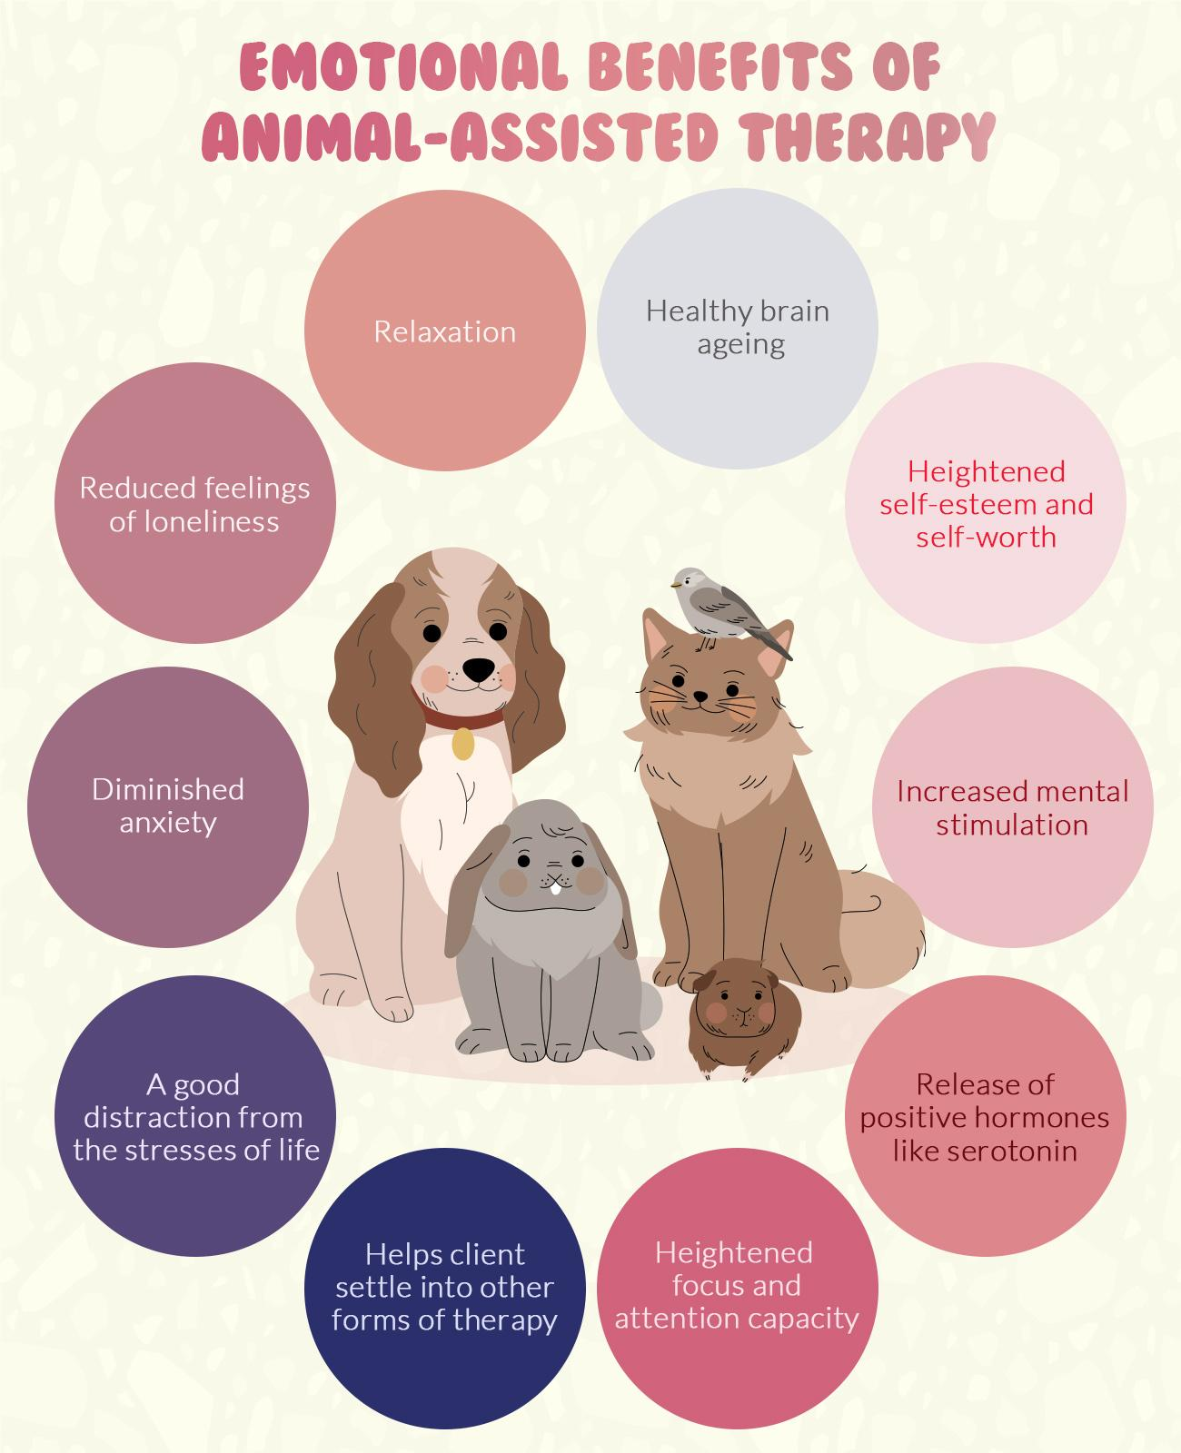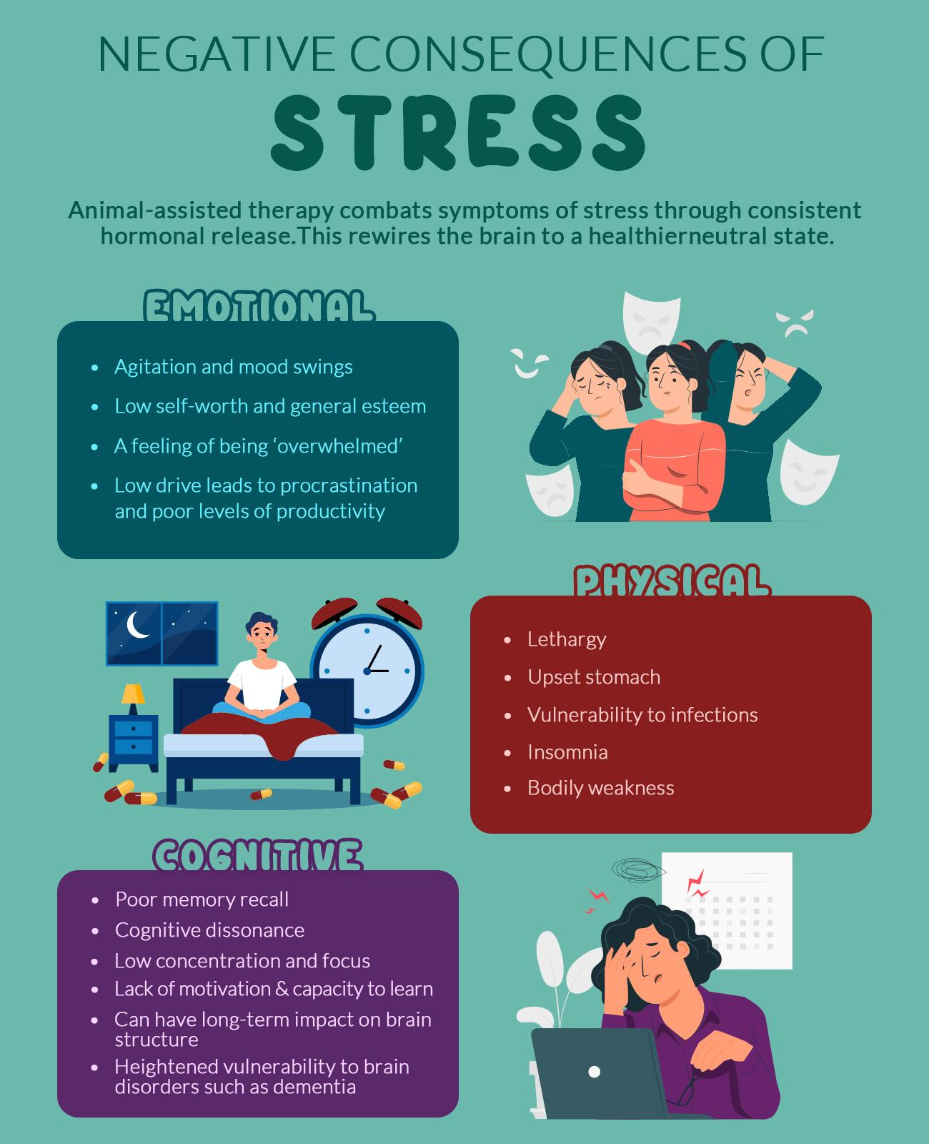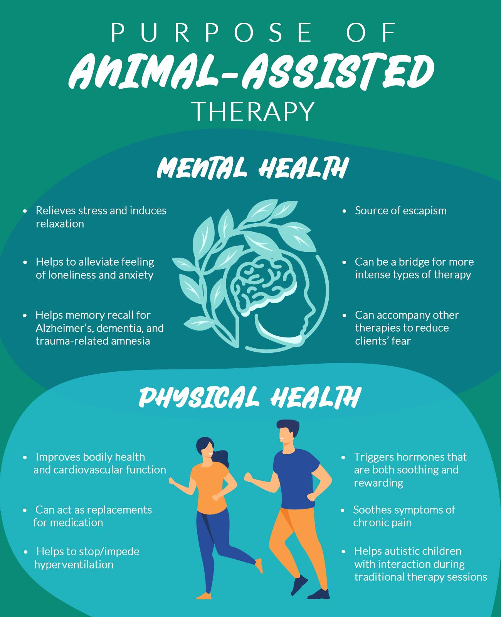

Important Documents to Review

* Certificate of Animal Assisted Therapy course completion and passed assessment
* Health and Vaccination records
* Informed Consent and Release of Liability

Certificate of Completion

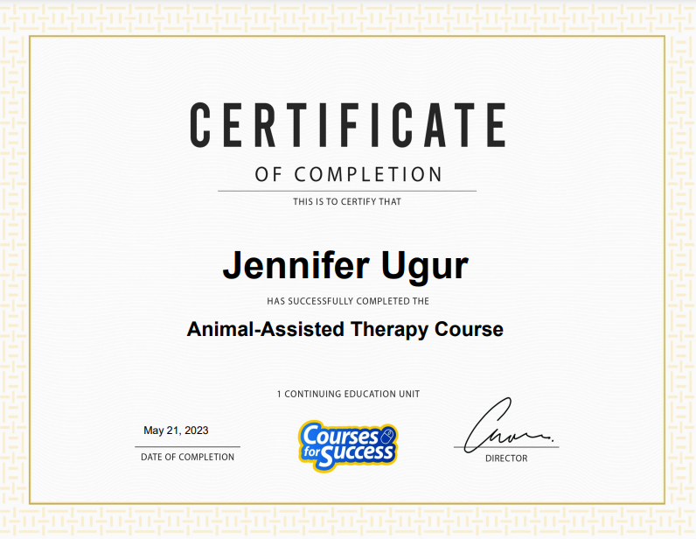

Informed Consent and Release of Liability

I incorporate my dog, Alpha into my psychotherapy work. I believe his presence benefits my clients & there are scientific studies that demonstrate this information. The use of animals by health professionals in their work is called animal assisted therapy or pet therapy. Numerous studies show that interacting with animals helps people lower their blood pressure, increases engagement & reduces anxiety & depression. This consent form outlines the risks & rules needed to ensure your health & safety (as well as Alphas) as we work together. What you need to know:

1. You may opt to not have Alpha in your sessions. Initial here if making that choice: _______

2. While Alpha has been screened by a veterinarian before commencing work as a therapy animal/pet, animals do

sometimes carry diseases. Because your contact is minimal, this risk is very small. Alpha is up to date on all his vaccinations.

3. While Alpha is a “hypoallergenic” dog (he has hair, not fur) there may still be a risk of an allergic reaction. Please let me know if you typically have allergies to animals.

4. If you or your child have a fear of dogs (however mild) then animal assisted therapy may not be appropriate for you. Let’s discuss potential risks & benefits prior to the start of our work together.

5. As Alphas’ handler & as your therapist I will be looking out for your welfare as well as his. However, it is important to remember that Alpha is an animal & as such can be unpredictable. Alpha is a gentle dog & affectionate dog, however, scratches, jumping, mouthing & unwanted kisses are all possible, especially during his first few encounters.

6. Animals have individual rights, just as each client has rights. Alpha gets to decide how & when he participates in the sessions. It is important for everyone’s benefit (as well as safety) that he is not coerced or mistreated. He typically greets people enthusiastically & then seeks to be petted.

7. Clients may not bring their own animal to also be involved in their therapy session. Let me know if you wish me to meet your animal, I can arrange for Alpha to be elsewhere during that session.

8. Confidentiality is important to Alpha. He won’t talk about you, but it is possible he may recognize you outside of a session. Don’t worry he's friendly with most people, so no one needs to know that he actually knows you.

While I have listed some common risks, I cannot foresee all potential risks. By signing this form you are stating your acceptance of the above rules & risks & agree to accept full liability in the event that Alpha harms you or your child in any way in the course of treatment or as a result of treatment. By signing this form, you are releasing Foundations Counseling Center from any liability should any injury occur as part of your animal assisted therapy.

**Statement of Understanding**

I understand that I have a right to a copy of this agreement. I have had any questions answered to my satisfaction**. I have read, understand, & agree to abide by this agreement & consent to participate in animal assisted therapy with Jennifer Ugur MS, LPC.**

Client Signature: Date:

Client/Parent/Guardian: Date:

Staff Witness: Date: